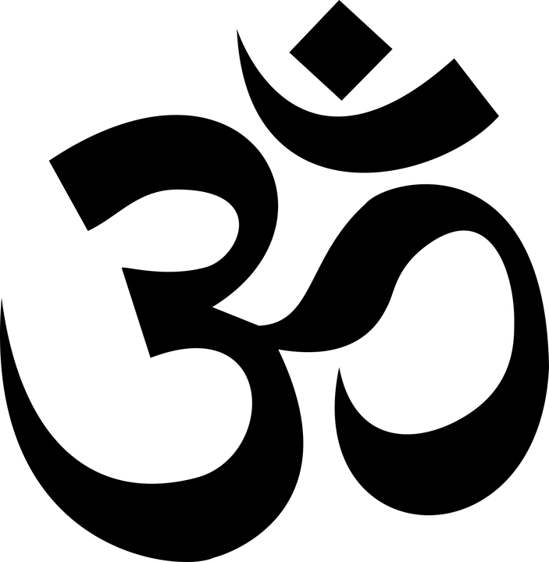

**Benefits of Pranayama and the twelve basic Asanas**

**Kapalabhati** (Cleansing Breathing Exercise)

* Cleanses the nasal passages and the entire respiratory system.
* Strengthens and increases the capacity of the lungs and the rib cage muscles.
* Helps to drain the sinuses and eliminates excess mucus.
* Removes bronchial congestion.
* Eliminates excess carbon dioxide, permitting red-blood cells to take more oxygen.
* Refreshes and invigorates the mind, increasing alertness.
* Stores prana (vital energy) in the solar plexus (neval) region.

**Anuloma Viloma** (Alternate Nostril Breathing)

* Cleanses and strengthens the entire respiratory system.
* Harmonizes the entire system and calms the mind.
* Increases the flow of oxygen from the lungs to the blood and enables more carbon dioxide (and other waste) to pass from the blood to the lungs for elimination during exhalation.

**Surya Namaskar** (The Sun Salutation)

* Makes the spine flexible. Stretches and strengthens all the major muscle groups in the body.
* Improves intake and flow of oxygen, stimulating the respiratory system and bringing increased blood flow, warmth and energy to the whole body.
* Relaxes the nerves, regulates breathing and focuses the mind.

**1. Sirshasana** (The headstand)

* Strengthens the respiratory and circulatory systems.
* Increases oxygen supply to the brain and sympathetic nervous system, improving memory and concentration.
* Relieves pressure on the lower back and aligns the spine.
* Relieves varicose veins (as does shoulderstand).
* Stimulates the pineal and pituitary glands.
* Counteracts nervous disorders and anxiety.

**2. Sarvangasana** (The shoulderstand)

* Regulates the thyroid gland. Improves metabolism and heat production and proper growth of muscles and bones.
* Benefits the heart rate, heart contractility and blood pressure.
* Stimulates and regulates the parathyroid glands which help to maintain proper calcium levels in the body.
* Keeps the neck and spine strong and elastic.
* Prevents blood from stagnating in the veins of the lower limbs.
* Removes mental sluggishness, insomnia and depression.

**3. Halasana** (The Plough)

* Increases flexibility in the neck and spine and opens up the spinal discs, rejuvenating the entire spine.
* Nourishes the spinal nerves.
* Strengthens muscles of the back, shoulders, and arms.
* Massages the internal organs.
* Relieves indigestion and constipation

**4. Matsyasana** (The Fish)

* Removes stiffness from the entire length of the spine, bringing increased blood supply to the back.
* Corrects round shoulders.
* Increases lung capacity, strengthens and cleanses the respiratory system. Relieves asthma.
* Stimulates and massages the parathyroid glands in the back of the neck, which protect bones and teeth.
* Stimulates the pituitary and pineal glands.
* Regulates moods, emotions and stress.

**5. Paschimothasana** (The Sitting Forward Bend)

* Stimulates digestive organs; increases digestive fire.
* Invigorates all internal organs; reduces body fat.
* Regulates the pancreas, which controls carbohydrate metabolism and blood sugar levels.
* Mobilizes joints, especially the hips.
* Invigorates the entire nervous system.
* Alleviates disorders of the genito-urinary system.

**6. Bhujangasana** (The Cobra)

* Massages and strengthens deep and superficial back muscles.
* Increases flexibility of the spine.
* Relieves back pain and kyphosis.
* Tones the abdominal organs, ovaries, uterus and adrenal glands.

**7. Salabhasana** (The Locust)

* Strengthens abdominal wall and lumber muscles.
* Improves digestion; massages the pancreas, liver and kidneys.
* Promotes flexibility of the cervical region of the back.
* Strengthens the biceps, deltoid muscles and back.
* Reduces lower back pain and sciatica.
* Increases space between the vertebrae.

**8. Dhanurasana** (The Bow)

* Promotes flexibility of the entire spine.
* Invigorates and massages the digestive organs.
* Alleviates constipation and indigestion.
* Regulates the pancreas.
* Strengthens the abdominal muscles.
* Prevents rheumatism of the legs, knees, and hands.

**9. Ardha Matsyendrasana** (The Half Spinal Twist)

* Keeps the spine elastic.
* Increases synovial fluid of the joints.
* Stimulates glucose release. Tones the sweat glands.
* Massages the abdominal muscles and digestive organs.
* Relieves constipation and other digestive problems.
* Tones and stimulates the sympathetic nervous system.
* Regulates the secretion of adrenaline and bile.
* Corrects stooping shoulders and poor posture.

**10. Kakasana** (The Crow)

* Strengthens and stretches the hands, arms, wrists and shoulders.
* Increases breathing capacity.
* Increases power of concentration.
* Promotes physical and mental balance.
* Removes lethargy.

**11. Padahastasana** (The Standing Forward Bend)

* Lengthens the spine and makes it supple.
* Mobilizes the joints and invigorates the entire nervous system.
* Increases the blood supply to the brain.
* Decreases abdominal fat.
* Relieves sciatica and low back pain.

**12. Trikonasana** (The Triangle)

* Tones the spinal nerves and abdominal organs.
* Promotes hip and leg flexibility.
* Strengthens the pelvic area.
* Massages and stimulates the liver and spleen.

**Savasana** (The Relaxation Posture)

* Allows the body and mind to rest and recharge.
* Distributes prana throughout the body.
* Enables the benefits of all the asanas to be assimilated.
* Facilitates the elimination of toxins.